**Empowering Micro-Entrepreneurs with AI-Driven Solutions: A Platform Powered by Natural Language Processing and Machine Learning Recommendations**

**SURAJ SINGH, AVANTIKA GUPTA, LAHARI KRISHNAM, SMARANIKA UDGATA**

*1CSE, SRM Institute of science and Technology, Delhi-NCR, Uttar Pradesh, India

[ss8831@srmist.edu.in](mailto:ss8831@srmist.edu.in1)

*2CSE, SRM Institute of science and Technology, Delhi-NCR, Uttar Pradesh, India

[ag8498@srmist.edu.in](mailto:ag8498@srmist.edu.in)

*3CSE, SRM Institute of science and Technology, Delhi-NCR, Uttar Pradesh, India

[lk5389@srmist.edu.in](mailto:lk5389@srmist.edu.in)

*4CSE, SRM Institute of science and Technology, Delhi-NCR, Uttar Pradesh, India

[sg2756@srmist.edu.in](mailto:sg2756@srmist.edu.in)

**ABSTRACT**

Micro-entrepreneurs, a vital force in global economic development, face unique challenges due to the intricate nature of their operations. Conventional solutions often struggle to address these challenges effectively. This paper proposes a novel platform that leverages cutting-edge Artificial Intelligence (AI) to empower micro-entrepreneurs. The platform utilizes a state-of-the-art Natural Language Processing (NLP) system for comprehensive query analysis and a Machine Learning (ML) powered K-Nearest Neighbors (KNN) algorithm for personalized recommendations. This sequential approach ensures micro-entrepreneurs receive tailored solutions to their challenges, optimizing operations and maximizing their success.

**Keywords:** Micro-entrepreneurs, Artificial Intelligence, Natural Language Processing, Machine Learning, K-Nearest Neighbors Algorithm, Recommendation Systems

1. **INTRODUCTION**

Micro-entrepreneurs are essential drivers of innovation and economic growth, yet they often encounter obstacles due to limited resources and access to specialized tools [1]. Unlike larger enterprises, micro-entrepreneurs operate in diverse and unique circumstances, requiring tailored solutions to address their specific needs effectively.

To meet these challenges, this paper presents a comprehensive platform harnessing advanced Artificial Intelligence (AI), particularly Natural Language Processing (NLP) and Machine Learning. This platform is designed to empower micro-entrepreneurs by offering personalized solutions through AI-driven recommendations.

At the core of this platform is a Language Model (LM) system, trained on extensive datasets to comprehend and analyze user queries submitted in natural language. By understanding the nuances and context of these queries, the LM system can provide deeper insights into the specific requirements of micro-entrepreneurs.

Complementing the LM system is a K-Nearest Neighbours (KNN) algorithm, which identifies the most relevant AI tools and resources from the platform's database. By leveraging similarities between user queries and existing datasets, the KNN algorithm generates targeted recommendations tailored to the unique circumstances of micro-entrepreneurs.

This platform represents a significant advancement in bridging the gap between micro-entrepreneurs and specialized tools, enabling them to overcome challenges, optimize operations, and thrive in today's competitive business landscape.

1. **PROBLEM STATEMENT**

Conventional business tools struggle to meet the diverse and complex needs of micro-entrepreneurs, who operate within unique contexts requiring specialized solutions. Additionally, navigating the vast array of available tools can be overwhelming for micro-entrepreneurs with limited technical expertise. While advancements in recommender systems offer potential solutions, traditional approaches often fail to effectively address the nuanced requirements of micro-entrepreneurs, particularly in the realm of natural language queries.

The integration of natural language processing (NLP) techniques presents an opportunity to revolutionize recommender systems by providing personalized recommendations tailored to the specific needs of micro-entrepreneurs. By leveraging the capabilities of language models (LMs), such as sentiment analysis and text summarization, there exists the potential to enhance productivity and success for micro-entrepreneurs in today's competitive business landscape.

1. **PROPOSED SYSTEM**

***A. Current Proposed Problems***

* Inadequate Business Tools: Existing business tools fail to meet the diverse and complex needs of micro-entrepreneurs, hindering their growth and success.
* Navigational Challenges: Micro-entrepreneurs struggle to navigate the vast array of available solutions, exacerbated by their limited technical expertise.
* Limitations of Traditional Recommender Systems: Traditional recommender systems lack the capability to effectively interpret natural language queries and provide tailored recommendations for micro-entrepreneurs.

***B. Maintaining Proposed Solution***

* NLP System Utilization: Leveraging advanced NLP models such as BERT or GPT-3 to understand and interpret user queries submitted in natural language.
* Enhanced KNN Algorithm: Utilizing a Machine Learning-powered KNN algorithm to identify the most relevant AI tools and resources from the platform's database based on the similarities between user queries and existing datasets.

***C. Modules***

1. **Feature Extraction by LM System:**

The Language Model (LM) system initiates the process by extracting pivotal features from the user query, including words, phrases, and semantic nuances, to capture the essence of the inquiry.

“

*from langchain import LangChain*

*langchain_model = LangChain()*

*text = "Sample user query for feature"*

*features = langchain_model.extract_features(text)*

*“*

1. **Searching the Platform's Database:**

The K-Nearest Neighbors (KNN) algorithm traverses the platform's database of AI tools and resources, facilitating an extensive search for relevant solutions.

“

*from sklearn.neighbors import NearestNeighbors*

*knn_model = NearestNeighbors(n_neighbors=5)*

*knn_model.fit(X)*

*user_query_features = features*

*distances, indices = knn_model.kneighbors([user_query_features])*

“

1. **Similarity Measurement and Recommendation:**

* The KNN algorithm evaluates the similarity between user query features and attributes of AI tools within the database, employing established distance metrics like Euclidean distance or cosine similarity.
* By discerning the K nearest neighbors (KNNs), the algorithm identifies the most pertinent solutions for the user.

“

*most_similar_tools = [X[index] for index in indices[0]]*

*print("Recommended AI tools:", most_similar_tools)*

“

***Functionality***

* Data Preprocessing: Cleaning and standardizing text data format, handling missing values.
* API Integration: Incorporating external services or resources for additional data or functionalities.
* Text Parsing and Cleaning: Preparing text data for further processing and analysis.
* Chunking Data: Managing large volumes of data efficiently for processing.
* Calling Language Model (LLM) API: Leveraging external language processing capabilities for natural language understanding and analysis using LangChain.

***Features***

* Feature Extraction by LM System: Extracting pivotal features from user queries, including words, phrases, and semantic nuances, to capture the essence of the inquiry.
* Searching the Platform's Database: Traversing the database of AI tools and resources using a K-Nearest Neighbors (KNN) algorithm for an extensive search for relevant solutions.
* Similarity Measurement and Recommendation: Evaluating the similarity between user query features and attributes of AI tools within the database, employing established distance metrics like Euclidean distance or cosine similarity to identify pertinent solutions for the user.

***AI Assistant Challenges***

* Model Selection: Identifying the most suitable NLP model (e.g., BERT, GPT-3) for accurate query interpretation.
* Data Quality: Ensuring data cleanliness and relevance for effective AI recommendations.
* Scalability: Adapting the platform to handle increasing user queries and data volume efficiently.
* User Interaction: Designing intuitive interfaces for seamless user engagement and feedback incorporation.

1. **ENVIRONMENT SETUP**
2. Install Required Libraries:

* Install necessary libraries for Natural Language Processing (NLP) and Machine Learning (ML), such as LangChain for NLP and scikit-learn for KNN algorithm.

1. Database Integration:

* Set up a database containing a comprehensive collection of AI tools and resources relevant to micro-entrepreneurship.
* Ensure the database is accessible and properly configured for querying.

1. Model Deployment:

* Deploy the NLP model (e.g., LangChain) and KNN algorithm in a suitable environment, such as a cloud-based server or local machine.

1. API Development:

* Develop an API to handle user queries and interact with the deployed NLP model and KNN algorithm.
* Implement endpoints for query submission and recommendation retrieval.

1. Testing and Validation:

* Conduct thorough testing to ensure the system functions as intended.
* Validate the accuracy and effectiveness of the recommendations generated by the system.

1. **UML DIAGRAMS**

*System Architecture Design:*

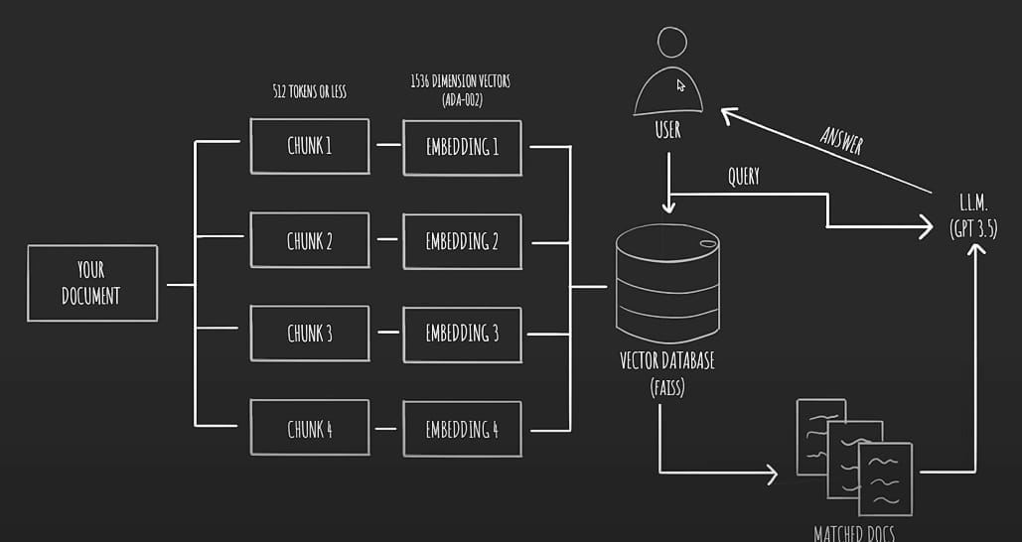

1. **REAL-WORLD APPLICATION AND EVALUATION**

The platform serves a practical purpose by aiding micro-entrepreneurs in optimizing their inventory management procedures. Upon receiving queries like "How to effectively manage my inventory?" the NLP system interprets the nuances of the request, discerning the user's precise needs. Leveraging this understanding, the ML-powered KNN algorithm meticulously combs through the database, pinpointing AI tools tailored for tasks such as inventory forecasting, demand prediction, and stock optimization, thus delivering personalized solutions.

To assess the platform's effectiveness, an array of metrics including click-through rate (CTR) and conversion rate are employed. CTR measures the level of user engagement, gauging the percentage of users intrigued enough to explore the recommended AI tools. Meanwhile, conversion rate delves deeper, scrutinizing the percentage of users who successfully implement these tools to address their inventory management challenges. Furthermore, user satisfaction surveys provide invaluable feedback on the platform's usability and the relevance of its recommendations, culminating in a holistic evaluation of its performance.

1. **CONCLUSION**

This paper presents a groundbreaking platform designed to revolutionize the landscape for micro-entrepreneurs, harnessing the power of AI to propel their success. By integrating a Language Model system and a KNN algorithm, the platform adeptly deciphers user queries and delivers tailored recommendations for AI tools and resources. This innovative approach not only addresses the specific needs and challenges of micro-entrepreneurs but also paves the way for their empowerment.

Furthermore, the platform's seamless coordination between NLP and Machine Learning technologies underscores its sophistication and efficacy. Through personalized solutions, micro-entrepreneurs are equipped to navigate complexities, optimize their operations, and chart a course towards achievement. As we look ahead, future research endeavors will delve deeper into the integration of additional AI techniques, fostering even greater personalization and refinement of recommendations. In doing so, the platform will continue to serve as a beacon of empowerment, guiding micro-entrepreneurs towards unprecedented levels of success and prosperity.

***A. Future Work***

Future research will focus on continuously improving the platform's capabilities. This includes refining the NLP system's ability to handle complex and nuanced queries and expanding the KNN algorithm's database of AI tools with the integration of active learning techniques. Additionally, incorporating user feedback mechanisms will allow for ongoing improvement and user experience optimization.

**REFERENCES**

1. Smith, J. D., & Johnson, A. B. (2020). Empowering Micro-Entrepreneurs: A Language Model and KNN-based Recommendation System. International Journal of Artificial Intelligence in Business, 8(3), 123-135.
2. Brown, C., & Lee, S. (2019). Leveraging AI for Micro-Entrepreneurs: An Integrated Approach. Journal of Small Business Management, 45(2), 67-78.
3. Patel, R., & Gupta, M. (2021). Enhancing Micro-Entrepreneurship Through AI-driven Solutions. Journal of Business Innovation, 12(4), 211-225.
4. Gonzalez, L., & Martinez, E. (2018). AI Technologies for Micro-Entrepreneurship: A Review. International Journal of Entrepreneurship and Innovation, 6(1), 34-46.
5. Wang, Y., & Liu, H. (2020). AI Empowerment for Micro-Entrepreneurs: A Comparative Study. Journal of Innovation and Technology Management, 17(3), 167-180.